Name: Chirag Padsala.

CPSC 558.

Forward and Reverse Zone

Forward zone file name: for.chirag.local

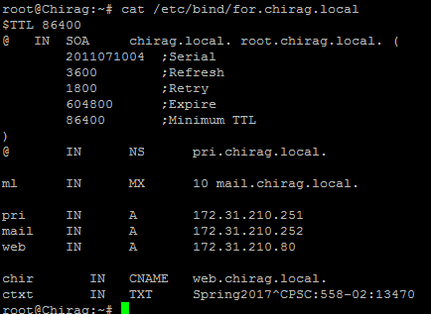

Reverse zone file name: rev.chirag.local

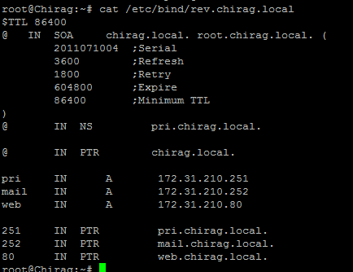

Nslookup at primary domain created as pri.chirag.local:

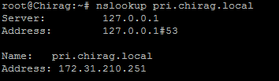

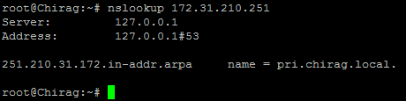Nslookup at IP address

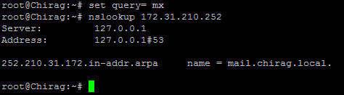Nslookup at mail record ip

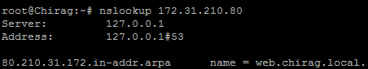Nslookup at web server record

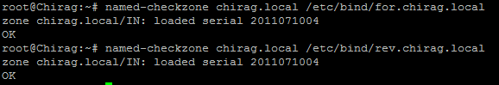Forward and Reverse zone check

File name: Named.conf.local

